Literacy Workbook

Topic: Food
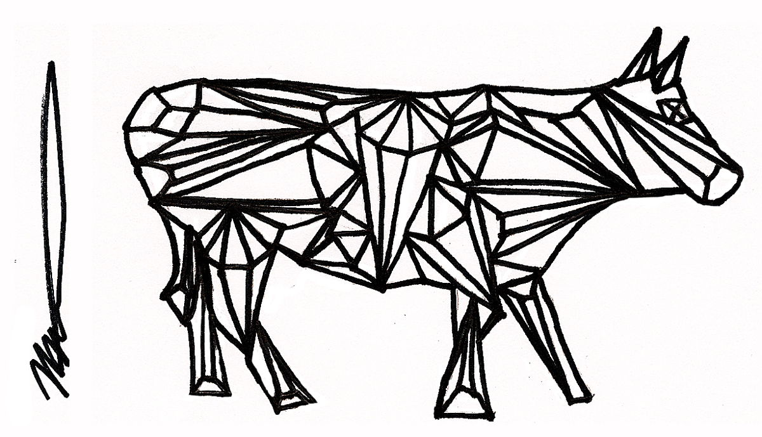

Name:

Verbs in recipes
A verb is often called a ‘doing word’. In cookery, you do a lot of things. Match up these cooking verbs to their meanings.
Word |  | Meaning
Fry |  | to cook in hot water on the top of the oven.
Bake |  | to combine ingredients together.
Stir |  | to cook in the oven
Boil |  | to move the ingredients with a spoon.
Pour |  | to cut with a knife.
Mix |  | to cook in oil, usually on the top of the oven.
Chop |  | to remove all the water.
Drain |  | to take the skin from something.
Season |  | to add salt and pepper or extra flavour.
Peel |  | to cook in hot water on the top of the oven.

Verbs have different endings depending on who is doing the action. For example: I chop the potato but Freddy chops the potato and Ms Khan is chopping the potato.
Use the correct verb and the correct ending to fill in the blanks in these sentences.

- You must ________________________ the carrot into batons.
- While the lasagne is ______________________ in the oven, prepare the salad.
- James __________________ the pasta with a colander. James is silly. He should’ve used a sieve.
- While you are ________________________ the onion, your friend can dab your eyes to wipe away the tears.
- While the onion ________________________ do nothing. Just enjoy the smell.
- Constantly ______________ the curry with a wooden spoon.
- You should ________________________ with salt. But not too much!
- Take care when __________________ hot liquids.
Subjects and verbs
If a verb is a ‘doing’ or ‘feeling’ word then there must be someone or something doing the doing or feeling! This person or thing is called the subject of the sentence. Write down the subject and the verb of each of these cooking sentences.

Example:
I like cooking.
Subject: I Verb: Cooking
Turning on the hob, James smiled.
Subject James Verb: Smiled

- Barry has always cooked well.
Subject: Verb:
- But he knows nothing about fruit!
Subject: Verb:
- His mother always shouted at him.
Subject: Verb:
- “You’ll never feed people well without fruit!”
Subject: Verb:
- She would say, sadly.
Subject: Verb:

- One day, this boy walked to the shops.
Subject: Verb:
- His mother’s words were ringing in his ears.
Subject: Verb:
- He saw the sign that said Greengrocers.
Subject: Verb:
- Entering the shop, Barry was amazed.
Subject: Verb:
- So many colours dazzled his eyes.
Subject: Verb:

Extension: Continue the story of Barry and his quest to discover healthy eating. Mark out the subject and the verb in each sentence you write.
Full stops and capital letters
You are the editor of a small magazine. One of your reporters has submitted a review of a local restaurant. Unfortunately, the shift and the full stop keys on their keyboard have stopped working. You’d better sort this out pronto with a red pen!

yesterday, i went to a new restaurant called ‘big billy’s brilliant burgers’ it is situated on the corner of argyle street and king street on entering the restaurant you are taken back at once by the shabbiness of the decoration the wallpaper is hanging off of the walls and i swear i stood in some grease on the floor we were shown to a table by an annoyed looking waiter who showed us to our table and threw a menu at us we waited over twenty minutes for our food and, when it came, it was disgusting I have never seen so much grease in my life have you ever tasted boiled rat meat i’m pretty sure i have now

Extension: Write a similar review of a restaurant (fast food or otherwise – even a takeaway!) you’ve been to recently. Remember to include what the staff were like, what the restaurant was like and how the food was!

Adjectives describing taste (basic, good, great)
Adjectives are words that we use to describe things. A good way to spice up your writing is to use good adjectives. Complete the following table of ways to describe taste. You might find a thesaurus helpful. You can find one online at thesaurus.com
OK adjective | Better adjective | Really good adjective
Tasty | Delicious | Scrumptious
 | Rotten
 |  | Cloying
Sour
 |  | Briny
Boring
Yummy

Writing about taste
Use at least some of the adjectives in the table above to describe the taste of your favourite food or meal. Try to use the ‘really good adjectives’
My favourite food is_____________________________________ it tastes

__________________________________________________________________________________

__________________________________________________________________________________

Compound sentences
We use conjunctions to join together two wee sentences into big ones. These big sentences are called compound sentences.

For example:
Adam doesn’t like burgers. Burgers contain mechanically recovered meat
Becomes:
Adam doesn’t like burgers because burgers contain mechanically recovered meat

Because is an example of a conjunction. Using conjunctions to create compound sentences is a way to make your writing flow and become simpler to understand.
Use some of the conjunctions in the box to create compound sentences out of the following examples.
And so or when but if because while

- You should never touch the hob. You will burn yourself if it is on.
________________________________________________________________________
- Frankie eats lots of fruit. Seema only eats sweeties.
________________________________________________________________________
- I like sushi. I like tempura.
________________________________________________________________________
- I’ll learn how to make sushi. Someone can teach me.
________________________________________________________________________
- You should eat more nuts. You can get more protein.
________________________________________________________________________
- You shouldn’t eat that many crisps. You don’t want to get ill!
________________________________________________________________________
- Don’t open the oven. There is a cake cooking. _____________________________________________________________________
- You will know the egg whites are beaten enough. They will stand up in stiff peaks. _____________________________________________________________________

Gary Ralston's restaurant review: La Vita Pizzeria, Bishopbriggs
- 06:00, 28 March 2015
- By Gary Ralston

GARY visits a popular Italian on the outskirts of Glasgow and is delighted to find La Vita's new look and great food are a winning combo. He gave it 26/30.

INTRODUCTION

If Italian eating is all about the family, then a little slice of La Dolce Vita is to be found in East Dunbartonshire.
The English translation of this stable of restaurants sprinkled around Glasgow is ‘The Life’ and
its heart is beating strong in Bishopbriggs.
A visit to La Vita in Kirkintilloch Road, now established for more than a decade, isn’t so much a stroll down memory lane as a venture into somewhere new, as owner Marco Arcari has recently spent a fortune on a re-fit.
No expense spared, sparkling chandeliers light up ruby red booths, offset by softer greys and glass wall features more akin to a VIP room in a nightclub.
It’s money well spent, although it’s just as well there isn’t an orchard out the back or it would have been shoogled free of its fruits within hours of the interior designer departing.
MEAL

We wangled a cosy corner booth, which would have been perfect if your dining partner was there to tickle your chin, rather than leaning over to check if you’d scrubbed behind your ears.
The menu follows the traditional Italian format of pasta, pizzas, risotto, steaks, chicken and fish, with a selection of burgers thrown into the mix.
La Vita plays it safe, preferring its chefs to cook by numbers, which stifles some of the individual creativity of its staff and prevents the overall experience rising from the very good to the excellent.
Marion enjoyed her starter of mozzarella fritta, balls of creamy cheese rolled in breadcrumbs and served with a tomato salsa, which packed a nice zing against the soft dairy texture. Yours truly went for a caprese salad with a difference – a mozzarella basket, atop a bed of fresh basil and cherry tomatoes, which oozed its soft, subtle cheese when poked by a knife.
Marion paid the price for devouring her filling starter with her main course, penne mia casa, as she struggled to finish the heaving bowl of chicken, broccoli, mushrooms, garlic, cheese and chilli, even as she enthused it had hit the spot.
Our waiter, whose attitude was first class, was quick to offer a doggy bag. La Vita has also invested in a wood-burning oven and my 12in house pizza, with a thin, crispy base, held its shape well despite its size.
It came with chicken and smoked bacon bits, a few of which were just a little too fatty, although the mozzarella and tomato base was spot on.
CONCLUSION

The bill was £57, more than a quarter of which went on diet coke and sparkling water at a hefty £2.45 a tall glass and £3.35 for a 500ml bottle.
It’s my own fault for not shimmying up a tree round the corner and pressing my own apple juice.
Adapted from the Daily Record http://www.dailyrecord.co.uk/lifestyle/food-drink/gary-ralstons-restaurant-review-la-5412558

Question | Comment
Audience
Who would be likely to read this article? Think about age, nationality etc.

Give a reason for your answer
Introduction
Write down three interesting facts from this section
Meal
Write down three interesting facts from this section

What is the author’s opinion of the meal?

Write down a piece of evidence from the text to support your answer.
What does the author mean in the last sentence that it was his fault for not “shimmying up an apple tree”?
Does this review do everything it needs to? Give one piece of advice to the author in order to improve his review.

