Literacy Workbook

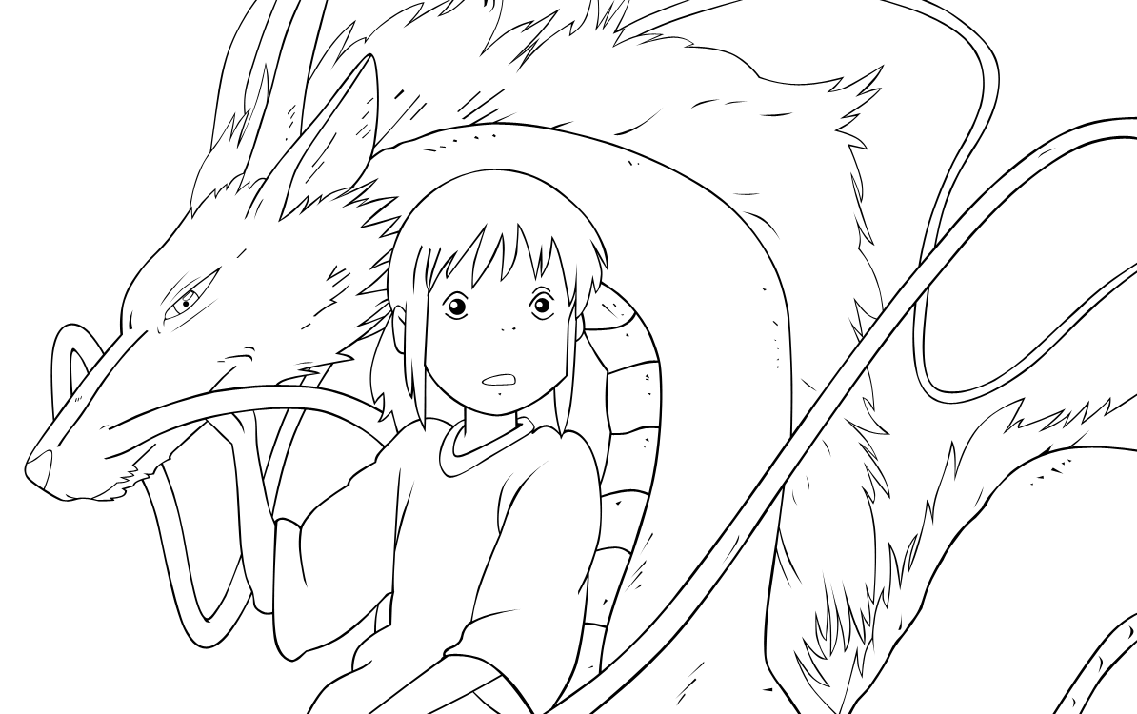
Topic: Manga

Name:
Using better verbs
A verb is often called a ‘doing word’. A common verb is walk. Good writers will use verbs which give more information about the action. Match up the verbs with their definitions and then choose the best verb for each picture.
Word |  | Meaning
Crawl |  | To walk quickly
Trip |  | To move slowly on all fours
Saunter |  | To walk with a lot of confidence
Stroll |  | To move with one leg wounded
Wander |  | To move wearily like you are stuck in mud
Limp |  | To move and fall over
March |  | To walk aimlessly
Strut |  | To walk in a slow and relaxed manner
Trudge |  | To take a leisurely walk

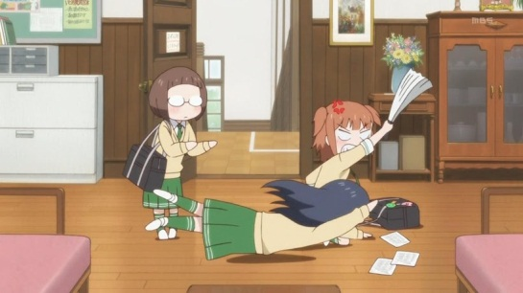
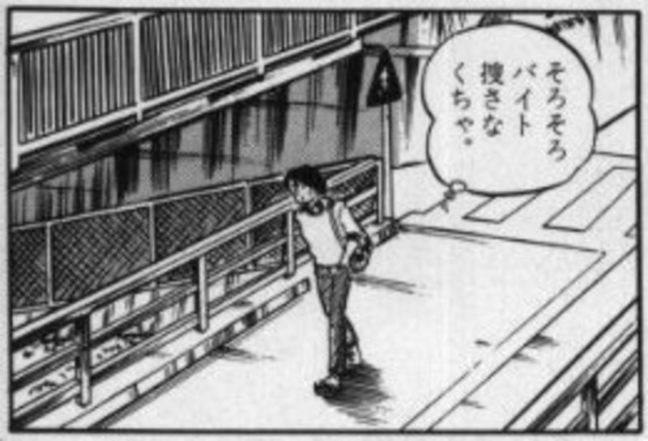

Kaneda ________________ down the street thinking of his terrible day.

Chihiro ______________________ over. She felt embarrassed.

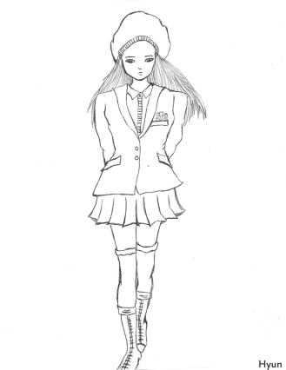
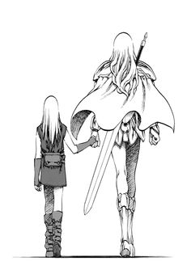
Pro tip:
Words with similar meanings are called SYNONYMS

Mei _________________________ to her next class: she was in no hurry.

The two lovers ______________________ away from the scene of their final battle

Subjects and verbs
If a verb is a ‘doing’ or ‘feeling’ word then there must be someone or something doing the doing or feeling! This person or thing is called the subject of the sentence. Write down the subject and the verb of each of these cooking sentences.

Example:
Tetsuo runs quickly
Subject: Tetsuo Verb: Runs
I think about kittent
Subject I Verb: Think

- Ichigo can see ghosts.
Subject: Verb:
- Rukia is defending Ichigo
Subject: Verb:
- I will arrest her!
Subject: Verb:
- The Soul Reapers make Ichigo a substitute.
Subject: Verb:
- Chronos rules one third of the world’s economy.
Subject: Verb:
- The Sweepers sail to the island.
Subject: Verb:
- Yabuki-san illustrates Black Cat.
Subject: Verb:
- People in Japan love manga.
Subject: Verb:
- Teachers should teach more anime.
Subject: Verb:
- Everybody loves Akira.
Subject: Verb:

Extension: Write about your favourite anime or manga character. Underline all of the verbs you use in one colour and the subjects in another.

Full stops and capital letters
You are the editor of a small magazine. One of your reporters has submitted a review of an anime. Unfortunately, the shift, full stop and question mark keys on their keyboard have stopped working. You’d better sort this out pronto with a red pen!

‘ghost in the shell’ is a great film and I would recommend it to all my friends the film is about a fear of technology the main characters in the film are motoko, batou and the puppet master the best thing about the film is the action scenes the reason i like this is because of the colours the director has also chosen good actors to play the roles of the characters their voices are emotive and make you think about what the character is thinking do you want an exciting action-adventure that has been a heavy influence on films like ‘the matrix’ then i recommend that you watch ‘ghost in the shell’

Extension: Write a similar review of an anime or manga. Include details about the plot, characters and why you liked or didn’t like it.

Adjectives describing characters (basic, good, great)
Adjectives are words that we use to describe things. A good way to spice up your writing is to use good adjectives. Complete the following table of ways to describe characters. You might find a thesaurus helpful. You can find one online at thesaurus.com
OK adjective | Better adjective | Really good adjective
Nice | Generous | Charitable
 | Greedy
 |  | Cloying
Nasty
 |  | Pugnacious
 | Peaceful
Pretty
 | Hideous

Writing about taste
Use at least some of the adjectives in the table above to describe a character of your own. Try to use some of the ‘really good’ adjectives.
My character is called_____________________________________ He/she/they are __________________
__________________________________________________________________________________
__________________________________________________________________________________
__________________________________________________________________________________
Compound sentences
We use conjunctions to join together two wee sentences into big ones. These big sentences are called compound sentences.

For example:
Adam really likes Akira. His favourite character is Kaneda.
Becomes:
Adam really likes Akira and his favourite character is Kaneda

And is an example of a conjunction. Using conjunctions to create compound sentences is a way to make your writing flow and become simpler to understand.
Use some of the conjunctions in the box to create compound sentences out of the following examples.

And so or when but if because while

- Many manga characters are chibi. Not all chibi characters are in manga.
__________________________________________________________________________
- He is the most kawaii character. He is very cute.
___________________________________________________________________________
- I will read that manga. It comes out in a week.
___________________________________________________________________________
- I will learn Japanese. I will be able to understand anime better.
___________________________________________________________________________
- I will lend you that DVD. You will promise to give it back.
___________________________________________________________________________
- You should learn about Japanese culture. You will understand more of the references.
___________________________________________________________________________
- It is a good film. The characters are believable. ___________________________________________________________________________
- It might be a fun film. It was very expensive to make. ___________________________________________________________________________

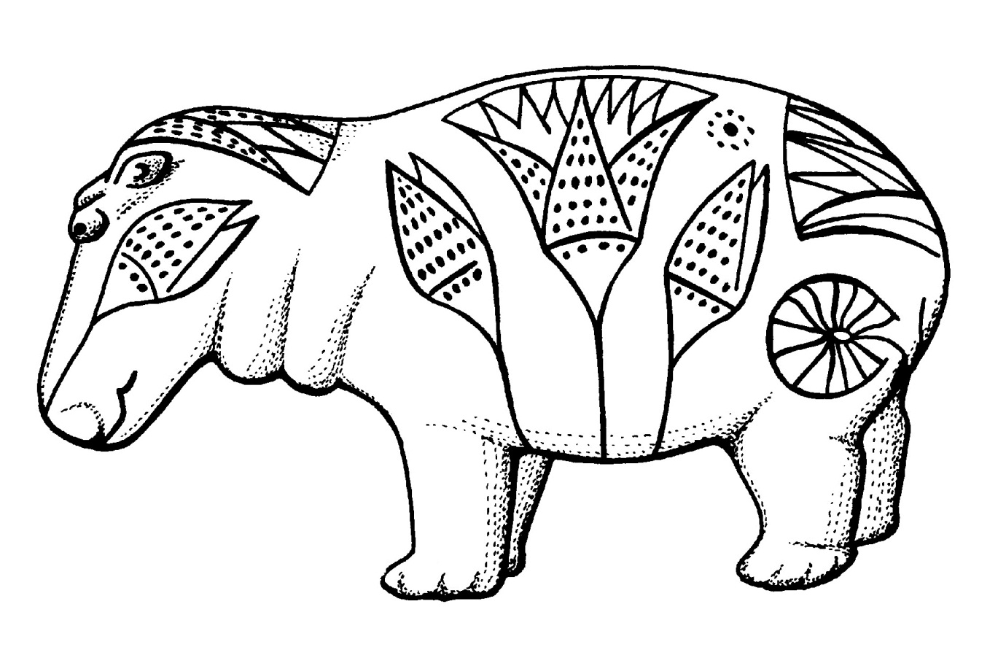

Close reading – Film review
Spirited Away
Plot
With her parents transformed into pigs after straying into what seems to be an abandoned theme park, a spoilt ten year-old girl takes a job in a bathhouse belonging to a haggard old crone and vows to deliver her family from its plight.
Review
We're all used to the Hollywood ballyhoo that accompanies the release of a new cartoon. But, for once, the fuss is entirely justified (and not a merchandising opportunity in sight), as Hayao Miyazaki's masterpiece has already notched up the notable double of the Golden Bear at Berlin (which it shared with Bloody Sunday) and an Academy Award.
It has also broken all Japanese box office records, becoming the first film to open in the States having already racked up $200 million. For this UK release, subtitled and dubbed options are available, depending on the venue. Pixar's John Lasseter has handled dubbing duties with typical sensitivity and, thus, opened up this magical experience to young and old alike.
Owing as much to Eastern mythology as to the works of Lewis Carroll or Mervyn Peake, this is an epic with a decidedly personal touch. The plot is gloriously maze-like and, as in most Miyazaki films, the quest element is key. But it's not as important as the themes of self-discovery and the value of relationships and, as a result, the action feels much closer to the little-seen My Neighbour Totoro than the overrated Princess Mononoke.
There are still numerous flights of fancy, however, as characters constantly shift shapes - Chihiro's parents turn into pigs, the evil Yubaba into a sinister bird, the timid No Face into a rampaging carnivore, Okutaresama the malodorous monster into a benign river spirit, and the kindly but mysterious Haku into a dragon. Then there's the spider-like boilerman, Kamaji, and his scurrying soot-ball assistants, who help Chihiro escape the forbidding bathhouse on a ghostly railway.
But what really fires the imagination is the beauty and ingenuity of the wonderland that lies at the end of a tunnel leading off from the quiet country road where Chihiro and her parents get lost. Moreover, the fact that Miyazaki and his team hand-draw the images before they're digitally coloured and animated gives them an artistry that has been woefully lacking from so many recent American features.
Verdict
Despite a dip midway through, this is a captivating fantasy that sets a new benchmark for animation.
Adapted from Empire magazine: http://www.empireonline.com/reviews/reviewcomplete.asp?FID=9366

Question | Comment
Audience
Who would be likely to read this article? Think about age, nationality etc.

Give a reason for your answer
Plot
Use your own words to describe the basic plot of the film
Review
Write down three interesting facts from this section. Use your own words as much as possible.
What is the author’s opinion of the film?

Write down a piece of evidence from the text to support your answer.
What does the author believe is missing from American animations?
Does this review do everything it needs to? Give one piece of advice to the author in order to improve his review.

