Mathematics Quiz

Addition

1. 23 + 34 = 2. 45 + 27 = 3. 63 + 79 =

Subtraction

4. 38 – 16 = 5. 57 – 26 = 6. 53 – 39 =

Multiplication

7. 2 x 11 = 8. 4 x 15 = 9. 16 x 4 =

Division

10. 24 ÷ 2 = 11. 36 ÷ 4 = 12. 128 ÷ 8 =

Perimeter

Calculate the perimeter of the shapes shown below: -

13. 14.
6cm

4cm 3cm
10cm

11cm

Area

Calculate the area of the shapes shown below: -

15. 16.

5cm

4cm 3cm

6cm

Fractions

Work out the fraction of each shape that is shaded: -

- 18.

19.

Time

20.

Write the letter matching each clock to the digital clock shown below

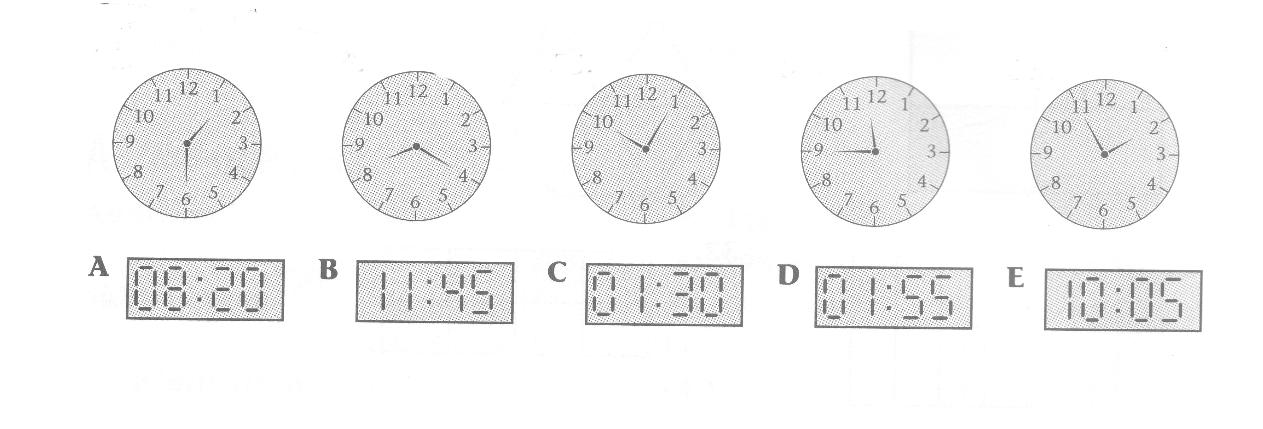

Graphs

21.

- What is the most popular flavour of crisps sold?
- What is the least popular flavour of crisps?
- How many packets of crisps are sold altogether?

22.

1. Which class had the highest attendance?
2. Which class had the lowest attendance?
3. How many pupils in 8Y attended?
4. How many pupils in 8H attended?
5. How many pupils in 8B attended?
6. How many pupils in 8N attended?
7 . How many pupils in 8C attended?
8. How many pupils in 8T attended?
9. Which classes had the same attendance?
10. Which class had 29 pupils attending?

Measuring

Measure the length of the lines shown below in centimetres: -

- . 24.

Measure the length of the lines shown below in millimetres: -

25. 26.

Tables

27.

Month | 7 nights | 14 nights | 21 nights
July | £200 | £349 | £435
August | £220 | £389 | £499
September | £189 | £239 | £350
October | £150 | £250 | £300

The table above shows the cost of a holiday on Paradise Island for one person

- Which month is it cheapest to go to Paradise Island for 14 nights?
- When is it most expensive to go to Paradise Island for 7 nights?
- How much would it cost to go to Paradise Island for 21 nights in September?

Money

28. £ 2.30 + £ 3.00 = 29. £3.29 + £4.50 =

30. £11.50 - £2.29 = 30. £11.89 - £6.90 =

